**Chapter Eight -- Traditional Peer Review vs. Contextual Analysis.**

**Abstract**

**Contextual Analysis offers a unique opportunity to enhance the peer review process by providing objective and comprehensive display of ideas considered by an author. Ideally, an article submitted for publication should contain a combination of established ideas and new ones. The objective should be to expand the body of knowledge. The challenge facing peer reviewers is to determine the importance of the contribution offered by an author. To accomplish this requires existing awareness of the body of knowledge and the ability to assess the importance of new contributions. Contextual Analysis offers an opportunity to make the determinations regarding a submitted article more transparent and objective.**

**Introduction**

**An article was selected randomly from those entered into PubMed during 2014, dealing with the subject of dog-related diseases. The article selected was assigned, by PubMed, the identification number – 24686032 – and can be retrieved by entering that number into the PubMed search box. The article was submitted to an international journal on November 11, 2013 and underwent peer review. Apparently, revisions and/or modifications were required. The revised manuscript was received by the journal on February 14, 2014, a delay of about 3 months. The manuscript was accepted for publication on March 26, 2014, (about 6 weeks later), electronically published 2 days later, and printed in paper format on April 2, 2014. The total period was over 4 months. A random sample of 12 articles entered into PubMed and studied for publication delay (receipt to publication) showed that 7 of the articles did not report that processing history. The five with such history showed a median of 4 months with a range of 7 (1 to 8) months.**

**Literature Review vs. Literature Analysis**

**Literature Review is a private, personal process involving a subject specialist who mentally compares the material offered in a proposed document with his/her personal knowledge base. In addition, the specialist is asked to determine the acceptability of the document to a mystical audience of journal readers.**

**Literature Analysis is a formalized comparison of the ideas presented in the proposed document with those provided by the world’s specialists. The intent is to build a description of the idea structure and to determine those that represent the established consensus view and those that contribute new information.**

**The two approaches differ in important ways:**

1. ***Review* involves an agreement between reviewer and author with respect to relevant knowledge and its presentation. *Analysis* involves identification of information provided by the author without assessing importance. The data extracted tends to be more complete containing information ranging from old to new.**
2. ***Review* is performed using personal and private procedures adopted by the specialists. *Analysis* employs procedures that can be quality-controlled and are more transparent.**
3. **The results of the *review* are private, shared with the editors, authors, and reviewers. The results of an *analysis* are public and can be displayed for all.**

**Analysis of Random Article**

**Exhibit 1 shows the abstract for the randomly selected article together with source data. Traditionally, a proposed manuscript would be read by two or more specialists to determine acceptability for publication. In contrast, an analysis compares the manuscript against the world’s knowledge. To do this, the informative terms presented by the authors in their sentences are identified by the analytic software. These terms are highlighted in red. The analytic strategy involves the following steps:**

1. **Segregate each sentence so that the ideas contained can be more easily identified.**
2. **Identify informative terms (nouns, adjectives, or gerunds) using software. The terms are identified and extracted based on suffixes and contextual associations presented by authors within each sentence.**
3. **Construct ideas consisting of pairs of informative terms within each sentence.**
4. **Determine the frequency of the authors’ ideas through time.**
5. **Identify the *relative importance* of the ideas by computing frequency over time.**
6. **Divide the ideas into those that occurred with high, moderate, low, and zero frequency. The highest frequency ideas could be considered to be the core ones. They form the foundation for the complete structure. The moderate and low frequency ideas could be considered the additional detail making a more complete idea structure. The zero frequency ideas represent the ones provided only by the authors of the manuscript and as such contribute new information to the idea structure.**

**Exhibit 1. Abstract 24686032 Selected at Random from Publications Entered into PubMed during 2014.**

**Source:** [**Mahmoudvand H**](http://www.ncbi.nlm.nih.gov/pubmed?term=Mahmoudvand%20H%5BAuthor%5D&cauthor=true&cauthor_uid=24686032)**1,** [**Fasihi Harandi M**](http://www.ncbi.nlm.nih.gov/pubmed?term=Fasihi%20Harandi%20M%5BAuthor%5D&cauthor=true&cauthor_uid=24686032)**2,** [**Shakibaie M**](http://www.ncbi.nlm.nih.gov/pubmed?term=Shakibaie%20M%5BAuthor%5D&cauthor=true&cauthor_uid=24686032)**3,** [**Aflatoonian MR**](http://www.ncbi.nlm.nih.gov/pubmed?term=Aflatoonian%20MR%5BAuthor%5D&cauthor=true&cauthor_uid=24686032)**4,** [**ZiaAli N**](http://www.ncbi.nlm.nih.gov/pubmed?term=ZiaAli%20N%5BAuthor%5D&cauthor=true&cauthor_uid=24686032)**5,** [**Makki MS**](http://www.ncbi.nlm.nih.gov/pubmed?term=Makki%20MS%5BAuthor%5D&cauthor=true&cauthor_uid=24686032)**6,** [**Jahanbakhsh S**](http://www.ncbi.nlm.nih.gov/pubmed?term=Jahanbakhsh%20S%5BAuthor%5D&cauthor=true&cauthor_uid=24686032)**1. Scolicidal effects of biogenic selenium nanoparticles against protoscolices of hydatid cysts.** [**Int J Surg.**](http://www.ncbi.nlm.nih.gov/pubmed/?term=24686032) **2014;12(5):399-403. doi: 10.1016/j.ijsu.2014.03.017. Epub 2014 Mar 28.PMID: 24686032**

***Cystic echinococcosis (hydatid cyst, CE) as a zoonotic parasitic infection caused by the larval stage of the dog tapeworm Echinococcus granulosus is still an important economic and public health concern in the world. One of the treatment options for CE is surgical removal of the cysts combined with chemotherapy using albendazole and/or mebendazole before and after surgery. Currently, many scolicidal agents, which have some complications, have been used for inactivation of the cyst contents. Therefore the development of new scolicidal agents with low side effects and more efficacies is an urgent need for surgeons. The present study was aimed to investigate the in vitro scolicidal effect of selenium nanoparticles biosynthesized by a newly isolated marine bacterial strain Bacillus sp. MSh-1 against protoscoleces of E. granulosus. Protoscolices were aseptically aspirated from sheep livers having hydatid cysts. Various concentrations (50-500 μg/ml) of Se NPs (in size range of about 80-220 nm) were used for 10-60 min. Viability of protoscoleces was confirmed by 0.1% eosin staining. The results indicated that biogenic Se NPs at all concentrations have potent scolicidal effects especially at concentrations 500 and 250 μg/ml after 10 and 20 min of application, respectively. In conclusion, the findings of present study proven that Se NPs have potent scolicidal effects, therefore may be used in CE surgery. However, the in vivo efficacy of these NPs remains to be explored.***

**Ideas Over Time**

**Table 1 shows the ideas provided by the authors in their abstract together with the frequency of use by other authors through time. The ideas are arrayed based on total use during the period 1980 to 2013. The core ideas (i.e., higher frequency through time) were respectively, dog with infection and health. The moderate ideas showed frequencies 43 to 229. The low frequency ideas ranged from 1 to 30. The new ideas supplied by the authors were not used in previous reports and were recorded as 0 frequency.**

**Table 1. Frequency of Occurrence Over Time. Ideas from Document 24686032.**

|  |  |  |  |  |  |  |  |  |  |
| --- | --- | --- | --- | --- | --- | --- | --- | --- | --- |
| **Primary** | **Related** | **Total** | **1980-84** | **1985-89** | **1990-94** | **1995-99** | **2000-04** | **2005-09** | **2010-13** |
| **Dog** | **Infect** | **4545** | **412** | **491** | **775** | **751** | **897** | **1167** | **52** |
| **Dog** | **Health** | **2240** | **76** | **158** | **244** | **354** | **402** | **861** | **145** |
| **Dog** | **echinococcus** | **229** | **13** | **31** | **39** | **22** | **25** | **79** | **20** |
| **Health** | **Infect** | **199** | **7** | **9** | **22** | **35** | **29** | **81** | **16** |
| **Echinococcus** | **Infect** | **125** | **11** |  | **23** | **18** | **25** | **42** | **6** |
| **Dog** | **Parasitic** | **117** | **2** | **6** | **6** | **9** | **10** | **45** | **39** |
| **Dog** | **Hydatid** | **78** | **4** | **15** | **18** | **10** | **5** | **21** | **5** |
| **Infect** | **Parasitic** | **74** | **2** | **6** | **7** | **12** | **11** | **33** | **3** |
| **Dog** | **echinococcosis** | **67** | **2** | **1** | **6** | **10** | **17** | **19** | **12** |
| **Dog** | **Larval** | **63** | **3** | **5** | **15** | **6** | **10** | **11** | **13** |
| **echinococcosis** | **Infect** | **59** |  | **22** | **4** | **8** | **10** | **13** | **2** |
| **Dog** | **Tapeworm** | **56** | **5** | **14** | **10** | **5** | **8** | **10** | **4** |
| **Hydatid** | **Infect** | **56** | **7** | **10** | **10** | **10** | **9** | **9** | **1** |
| **Infect** | **Larval** | **53** | **3** | **4** | **10** | **6** | **7** | **17** | **6** |
| **echinococcosis** | **echinococcus** | **49** |  | **2** | **4** | **8** | **8** | **22** | **5** |
| **Infect** | **tapeworm** | **49** | **5** | **9** | **10** | **3** | **13** | **7** | **2** |
| **echinococcus** | **Hydatid** | **43** |  |  | **17** | **7** | **3** | **11** | **5** |
| **echinococcosis** | **Health** | **30** | **1** | **8** | **2** | **1** | **3** | **11** | **4** |
| **echinococcosis** | **Hydatid** | **30** | **1** | **3** | **7** | **6** | **4** | **8** | **1** |
| **echinococcus** | **tapeworm** | **24** |  |  | **6** | **6** | **5** | **4** | **3** |
| **Hydatid** | **Liver** | **20** |  |  | **6** | **2** | **3** | **5** | **4** |
| **echinococcus** | **Larval** | **17** |  |  | **1** | **3** | **4** | **8** | **1** |
| **Hydatid** | **Tapeworm** | **17** |  | **3** | **5** | **4** | **2** | **2** | **1** |
| **Aspirate** | **Liver** | **16** |  | **1** | **1** | **1** | **2** | **3** | **8** |
| **echinococcosis** | **Larval** | **15** |  | **1** |  | **3** | **3** | **7** | **1** |
| **echinococcosis** | **tapeworm** | **15** |  | **5** | **3** | **2** | **1** | **2** | **2** |
| **Health** | **Hydatid** | **15** | **1** |  | **1** | **1** | **5** | **6** | **1** |
| **Health** | **Parasitic** | **12** |  |  |  | **1** | **3** | **6** | **2** |
| **echinococcus** | **Parasitic** | **11** | **1** |  | **2** | **2** |  | **4** | **2** |
| **echinococcosis** | **Parasitic** | **10** |  |  | **2** | **1** | **1** | **4** | **2** |
| **echinococcus** | **Health** | **9** |  |  |  | **1** | **3** | **4** | **1** |
| **Hydatid** | **Parasitic** | **9** |  |  | **2** | **2** | **1** | **4** |  |
| **Hydatid** | **Larval** | **8** |  |  | **1** | **1** | **2** | **3** | **1** |
| **Larval** | **tapeworm** | **8** |  |  | **2** | **1** | **2** | **3** |  |
| **Health** | **Larval** | **5** |  |  |  | **1** | **2** | **2** |  |
| **Health** | **tapeworm** | **5** |  | **1** |  |  | **2** |  | **2** |
| **Albendazole** | **mebendazole** | **4** |  |  |  | **3** | **1** |  |  |
| **Larval** | **Parasitic** | **4** |  |  |  | **1** |  | **2** | **1** |
| **Bacillus** | **Bacterial** | **3** |  |  |  |  |  | **2** | **1** |
| **Parasitic** | **tapeworm** | **2** |  |  | **2** |  |  |  |  |
| **Aspirate** | **Hydatid** | **1** |  |  |  |  |  | **1** |  |
| **Albendazole** | **chemotherapy** | **0** |  |  |  |  |  |  |  |
| **Aseptic** | **Aspirate** | **0** |  |  |  |  |  |  |  |
| **Aseptic** | **Hydatid** | **0** |  |  |  |  |  |  |  |
| **Aseptic** | **Liver** | **0** |  |  |  |  |  |  |  |
| **Bacillus** | **Selenium** | **0** |  |  |  |  |  |  |  |
| **Bacterial** | **Selenium** | **0** |  |  |  |  |  |  |  |
| **chemotherapy** | **mebendazole** | **0** |  |  |  |  |  |  |  |

**.**

**Description of Existing Ideas**

**The previously studied ideas are shown as an idea structure in Figure 1. The informative terms are shown as nodes and the ideas representing pairs of these terms are shown by the links between the nodes. This structure shows that all of the ideas have been considered by previous authors and were included by the authors of the new manuscript.**

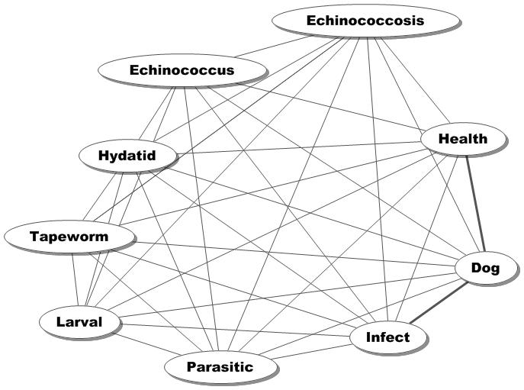**Figure 1. Ideas Considered Through 1980-2013.**

**Contribution of New Ideas**

**Figure 2 shows the new ideas provided by the authors. Their focus went beyond the description provided by the structure in Figure 1 and considered therapy. To do that, they linked two forms of chemotherapy with a bacterium obtained from liver.**

**The results of their study are summarized in Figure 3 which shows the combined idea structure. The previous reported ideas are in black and the authors’ new ideas in red. The link between the two idea sets is via the hydatid node. As expected when the idea structure is expanded, new questions emerge. The authors recognized that and suggested in their concluding sentence that – “*However, the in vivo efficacy of these NPs remains to be explored.”***

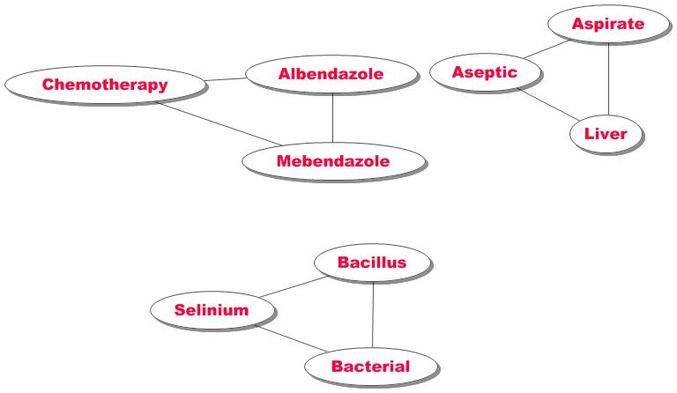**Figure 2. Ideas Contributed by Document Abstract 24686032**

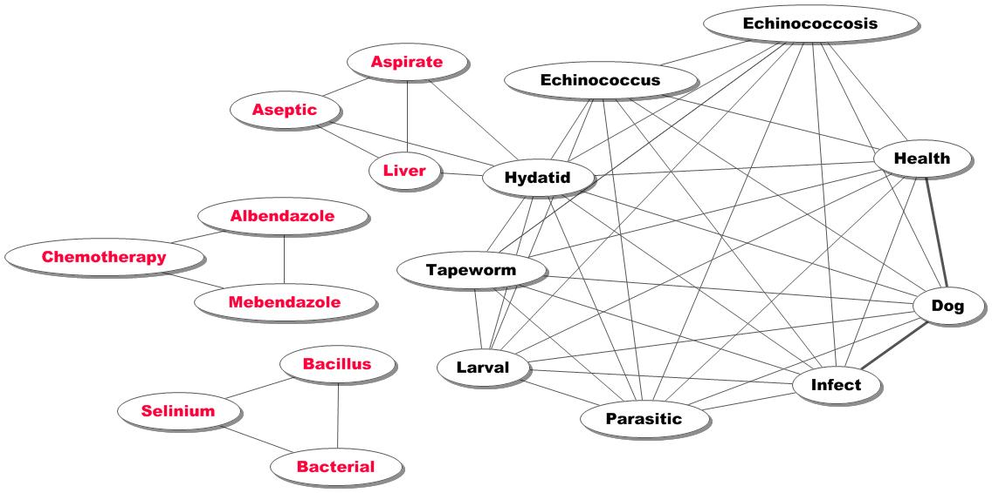**Figure 3. Complete Idea Structure Considered by the Authors of Document 24686032.**

**Changing Peer Review Criteria**

**In addition to a plethora of journals, the quality of the peer review performed has been challenged. Political and economic factors have altered the degree of expertise involved. A review often is based on assessment of presumed acceptance by a mystical audience of readers of the journal. This attempt to reach a particular but unknown audience may have changed the actual criteria used in assessment. The stated objective of the scientific report includes determination of advancement of knowledge. This may significantly contrast with the notion that the manuscript must be acceptable to some audience.**

**Ideas and Alternative Information Processing**

**Ideas have long been recognized as important building blocks in forming concepts, issues, and topics. They also serve as a desirable way of assessing the value of a manuscript. As seen in the above analysis, ideas can be useful in determining a form of consensus provided by the true peers of the authors preparing the new manuscript. Instead of singling out two or three individuals to review a proposed report, the entire population of peer-authors can be employed. This was shown in Table 1 by tracking through time the ideas employed by the authors of the new. As was seen in Table 1, the ideas could be divided into high, moderate, low, and zero frequency. The first three groups represent existing understandings of the topic. The last group contains the new ideas contributed by the authors of the manuscript. Figure 3 showed these ideas. The resulting structure shows what previous authors contributed to understanding, the potential contribution of the authors of the new manuscript, and opens the door to new studies.**

**Benefits of Idea Analysis**

**The process relies heavily on separation of the tasks into those that can be best performed by software, technicians, or subject experts. This assignment of tasks accelerates development of new approaches and resources. A particularly important shift is from the search-retrieval-analysis process to the application of higher cognitive functions (synthesis, comparison, evaluation, judgment, and application). Focus on those functions stimulates development of measures, criteria, and decision-rules. These are the necessary and important tasks associated with creativity.**

**In contrast to traditional procedures, emphasis on the higher cognitive functions enhances intellectual accomplishment in less time and with less clerical/mechanical effort. Using the traditional approaches, the time required to develop an innovative strategy could be years.**

**Assume that effective, objective, and expert assessment of manuscripts can be accomplished using modern information processing methods. These would include:**

1. **A *comprehensive resource of essential data* describing the existing scientific publications dealing with a subject. Essential data consist of ideas supplied by subject specialist-authors.**
2. **A *Contextual* *Analysis system* that identifies the ideas provided in the manuscript.**
3. **A *procedure for comparing the new ideas* with the existing set.**
4. **An *assessment process* that classifies the manuscript in terms of contribution to the body of knowledge.**
5. **New ideas stimulating a shift in description of the subject.**
6. **Ideas contributing to better understanding of an existing description.**
7. **Ideas contributing new methods in describing an existing phenomenon.**
8. **Ideas and methods representing well studied approaches.**

**Of these categories, the first three would provide useful information. The fourth category would require more detailed and traditional assessment in order to determine its merits. That means that the process involved in processing the bulk of new manuscripts can be significantly accelerated and publication can be distributed rapidly to the peer investigators. Institutional repositories can be employed to provide a second outlet.**

**Summary**

**Literature Analysis is a new approach to the problem of determining content of scientific documents and classifying them with respect to contribution to knowledge. The process employs contributions from all of the world’s experts by comparing the ideas provided in the new manuscript with those from the world’s literature. Of importance, the evaluation process is more transparent and can be quality-controlled.**

**As a result, the time required for evaluation and acceptance can be significantly reduced. Accepted manuscripts can be published immediately with distribution to those investigators who are recognized peers. By eliminating the subjectivity associated with existing peer review, distribution of new science can be made more effective. By enhancing the flow of new information and by removing barriers to effective information utilization, more individuals may elect to perform research. As a result, problems that have taken years of study could be approached with new procedures and perspectives.**